Phase 1: Configure the Risk "Rules of Engagement"
Before you can create a risk, you must define the math and boundaries the system will use.

1. Create Risk Classifications
- Navigate to Risk Management > Asset Risk Management > Settings > Classifications.
- Add two "Types" of classifications (the axes of your matrix):
  - Type 1: Likelihood (Values: 1-Rare, 2-Possible, 3-Certain).
  - Type 2: Impact (Values: 1-Low, 2-Medium, 3-High).
- Assign a numerical value (1, 2, 3) to each. Eramba needs these numbers for the math.

2. Set the Calculation Method
- Go to Settings > Calculation Method.
- Choose Multiplication (Likelihood × Impact).
  - Example: A "Possible" (2) likelihood and "High" (3) impact will result in a Risk Score of 6.

3. Define Risk Appetite
This tells Eramba when to "turn the light red."
- Go to Settings > Risk Appetite.
- Set your Threshold. For this lab, set it to 5.
  - Result: Any risk with a score of 6 or higher will automatically trigger a "Risk above appetite" status, signaling it needs urgent treatment.

Phase 2: Build the Organizational Context
Risks don't exist in a vacuum; they belong to departments.

4. Create a Business Unit & Process
- Navigate to Asset Management > Business Units.
- Click Actions > Add. Name it "IT Operations".
- Once the BU is created, go to the Processes tab (or click the process column in the BU row).
- Add a new Process: "User Identity Management".
  - Link this process to the IT Operations BU.

5. Create an Asset
- Navigate to Asset Management > Assets.
- Click Actions > Add.
- Name: "Active Directory Server."
- Type: Select "Systems/Hardware."
- Business Unit: Link this to "IT Operations."
  - Critical Note: In Eramba, the Business Unit is the Owner of the Asset.

Phase 3: Identify and Analyze Asset Risks
Now we bring it all together.

6. Create Asset Risks
- Navigate to Risk Management > Asset Risk Management.
- Click Actions > Add.
- The Context:
  - Risk Title: "Unauthorized access to AD via compromised credentials."
  - Asset: Select your "Active Directory Server."
- The Analysis (The Math):
  - Under the Analysis tab, select Likelihood: 2 (Possible) and Impact: 3 (High).
  - Eramba will instantly calculate the Risk Score: 6.
- The Status:
  - Save the risk. Because 6 is higher than your Risk Appetite (5), you will see a Red Status Label on your dashboard.

Create risk classification
prior to creating a risk
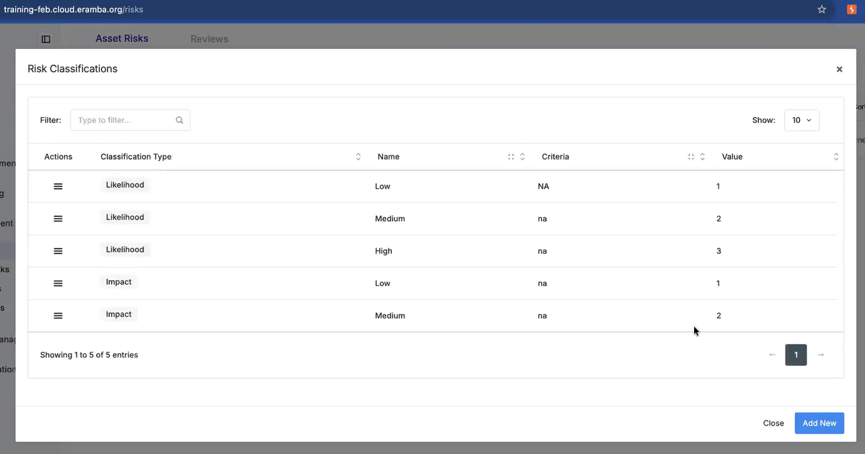
Once risk classification is defined,

set a calculation method
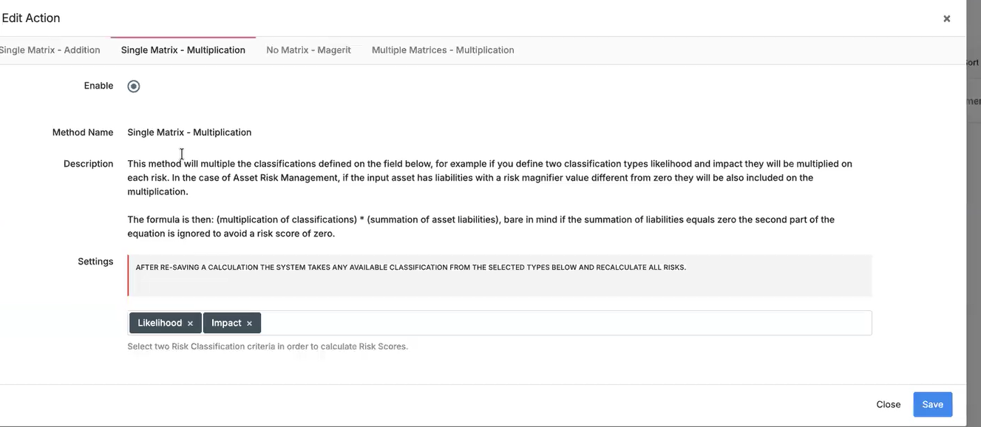

Set risk appetite

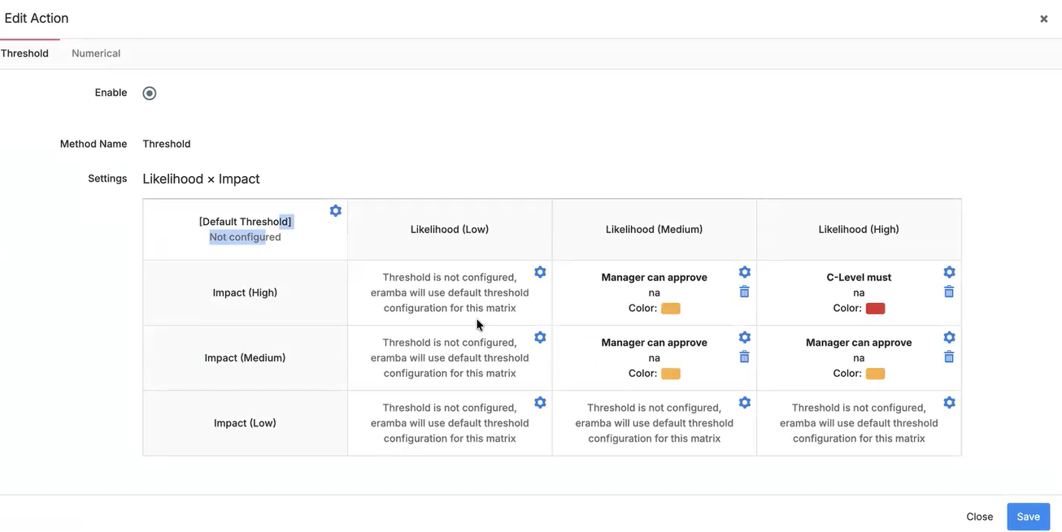
- Replicating the below in eramba
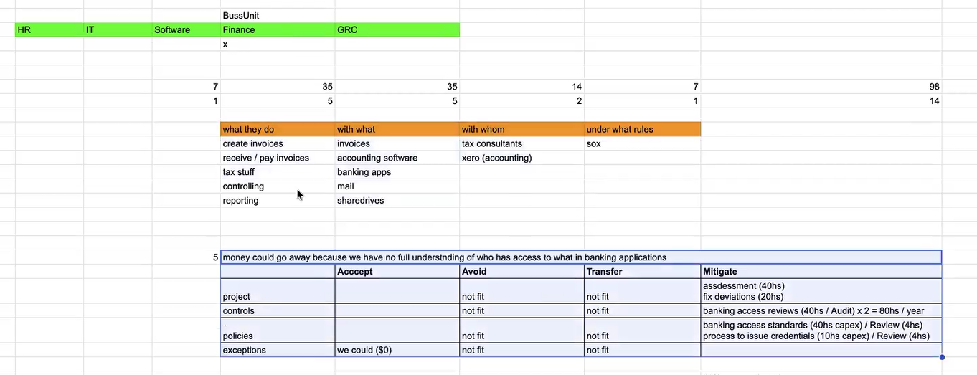

Create business unit
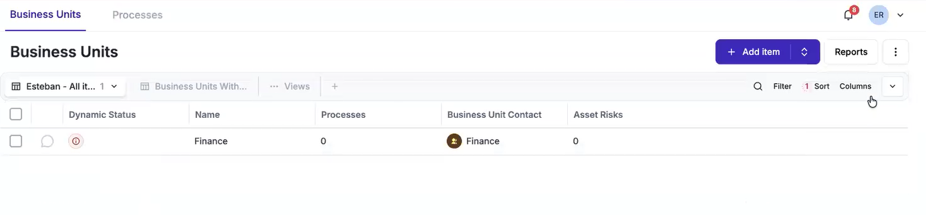

Create process
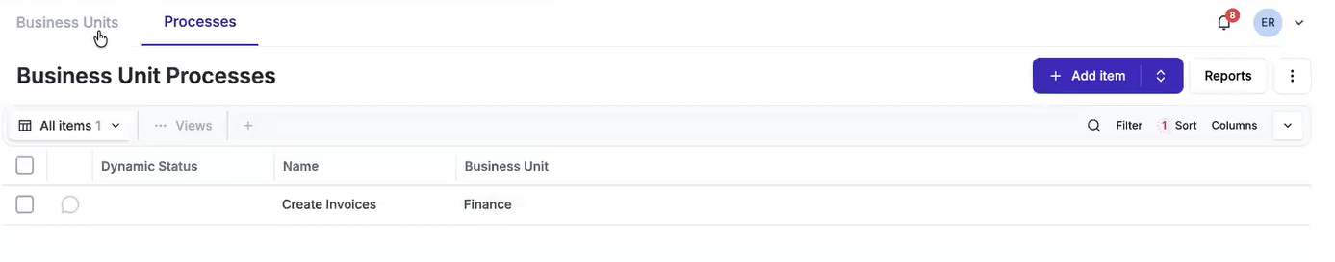

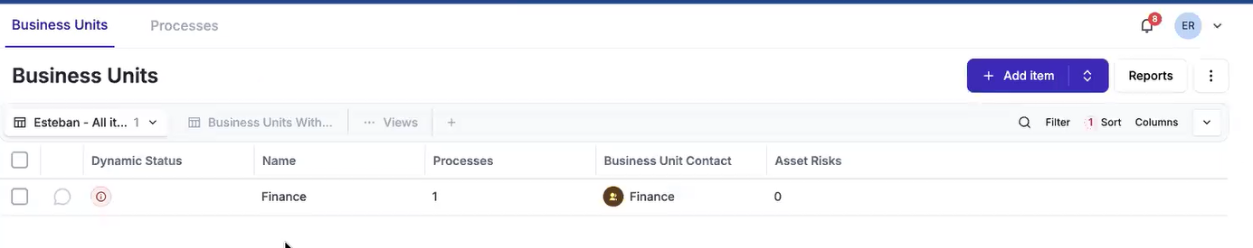

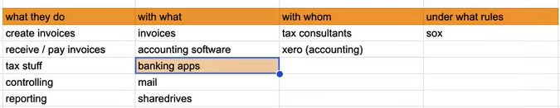

Create Asset
Create an asset called banking application. To create an asset, we need a business unit.

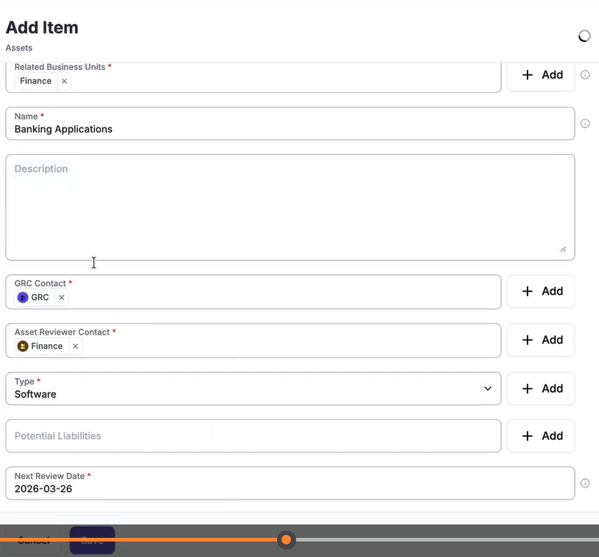

create asset risks
By filling all the general, analysis and treatment tabs

